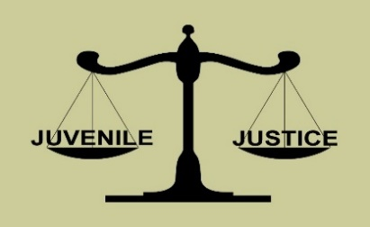 | Hoke County Juvenile Crime Prevention Council  Wednesday, January 20th, 2021  1:00 p.m.  Electronic Meeting via “Zoom”  Meeting Agenda
JCPC Board Members:

Rev. Al Anderson, Chairperson
Member of Faith Community

Linda Revels, Vice Chair
Member of Business Community

Det. Sgt. Yurika Lorenzo
Chief of Police Designee

Hoke County Sheriff Designee

Ronald Flippin
School Superintendent Designee

Yohan Namkung
District Attorney Designee

Randy Jones
(Keith Bullard, Designee)
Chief Court Counselor

Megan Tarver, Designee
Director LME/MCO Designee

Gwen McGougan
County Manager Designee

April Locklear
DSS Director Designee

LuEvelyn Tillman
Substance Abuse Professional

Commissioner James Leach
County Commissioner Chairman

Lauren Garcia
Youth Under Age 21

Tom Landry
Family Advocate

Raemi Cobb
Attorney

Judge Don Creed
Chief District Court Judge

Isley Cotton
Health Dept. Director Designee

Robert Smith
Nonprofit Representative

Dr. Sad’a Ray
(LaKendrick Smith, Designee) Parks & Recreation Representative

Gwendolyn Quick
County Commissioner Appointee

Jackie McLean
County Commissioner Appointee

Shirlyn Morrison-Sims
County Commissioner Appointee

Daphne Dudley County Commissioner Appointee

Don Woods
County Commissioner Appointee

Shirley Hart
County Commissioner Appointee

Michael Caulder
County Commissioner Appointee

Call to Order JCPC Chair

Invocation

Reports from JCPC Funded Youth Program JCPC Chair

- Road to Success Mentoring Program Ms. Patrell Ray
- Rebuilding the Dream Structured Day Program Ms. Ophelia Ray
- Y.E.S. Community Service & Restitution Program Ms. Brittany Gillespie
- Project Reverso Teen Court Program Ms. Brandy McPherson

Approval of Meeting Minutes (board action) JCPC Chair
- November 18th, 2020 regular meeting

JCPC Coordinator’s Report JCPC Coordinator
- FY 2020-21 Administration Budget Update
- Budget Revision

JCPC Sub-Committee Reports JCPC Vice Chair

- Risk & Needs Assessment Committee Mrs. Isley Cotton
- Approval of FY 2020-21 Annual Planning Summary (board action)
- Discuss option of 2-Year Planning Cycle

- Funding Committee Mrs. Daphne Dudley
- Review and Approve RFP Distribution List for FY 2021-22 (board action)
- Discuss option of 2-Year Funding Cycle

NC DPS Area Consultant’s Update Mr. Lance Britt
- Present Template of Request for Proposals FY 2021-2022 (board action?)

New Business Items JCPC Chair
- Discuss Issue of Programs’ Late Disbursement Checks

Announcements JCPC Chair

Adjournment (board action) JCPC Chair

