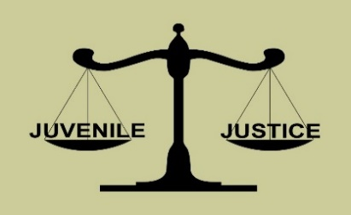 | Hoke County Juvenile Crime Prevention Council  Wednesday, August 19th, 2020  1:00 p.m.  Electronic Meeting via “WebEx”  Meeting Agenda
JCPC Board Members:

Rev. Al Anderson, Chairperson
Member of Faith Community

Linda Revels, Vice Chair
Member of Business Community

Chief Marc Godwin
Chief of Police

Lt. Scott McInnis
Hoke County Sheriff Designee

Brandon Locklear
School Superintendent Designee

Yohan Namkung
District Attorney Designee

Randy Jones
(Keith Bullard, Designee)
Chief Court Counselor

Rita Monroe
(Megan Tarver, Designee)
Mental Health Director Designee

Gwen McGougan
County Manager Designee

April Locklear
DSS Director Designee

LuEvelyn Tillman
Substance Abuse Professional

Commissioner James Leach
County Commissioner Chairman

Lauren Garcia
Youth Under Age 18

(VACANT SEAT)
Youth Under Age 18

Raemi Cobb
Attorney

Judge Don Creed
Chief District Court Judge

Isley Cotton
Health Dept. Director Designee

Robert Smith
Nonprofit Representative

Sad’a Ray
(LaKendrick Smith, Designee) Parks & Recreation Representative

Gwen Quick
County Commissioner Appointee

Jackie McLean
County Commissioner Appointee

Shirlyn Morrison-Sims
County Commissioner Appointee

Daphne Dudley County Commissioner Appointee

Don Woods
County Commissioner Appointee

Shirley Hart
County Commissioner Appointee

Michael Caulder
County Commissioner Appointee

Call to Order JCPC Chair

Invocation Lt. Scott McInnis

Reports from JCPC Funded Youth Program JCPC Chair

- Road to Success Mentoring Program Ms. Patrell Ray
- Rebuilding the Dream Structured Day Program
- Y.E.S. Community Service & Restitution Program Ms. Brittany Gillespie
- Project Reverso Teen Court Program Ms. Brandy McPherson

Approval of Meeting Minutes (board action) JCPC Chair
- Regular JCPC meeting 6-17-20

JCPC Coordinator’s Report JCPC Coordinator
- FY 2019-2020 Admin Budget Update
Final Accounting
- FY 2020-2021 Admin Budget Update
- Conflict of Interest forms

JCPC Sub-Committee Appointments JCPC Vice Chair

NC DPS Area Consultant’s Update Mr. Lance Britt
- JCPC Policy & Procedure Changes (House Bill 593)

New Business Items / Announcements JCPC Chair
- “NC Fall Festival” canceled (no opportunity for JCPC exposure)
- “Hometown Christmas” event?
- Discuss Eliminating Meetings for Oct. & Dec. (board action)

Adjournment (board action) JCPC Chair

ATTENTION: New JCPC Board Members
Brief JCPC Member Orientation offered immediately after adjournment.
ALL are welcome as a “refresher”!

